Makanyane Volunteers Guidelines: 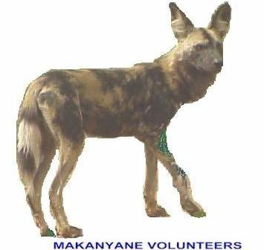

- As a Volunteer group we have realized that we need to have a set of guidelines which will be handed to all members so that every one knows what is expected of them in order to make everyone’s time enjoyable over the weekend.
- A fee of R100 per person will be asked for the weekend, This is to buy petrol, weed eater cord and tools etc..
- As a volunteer group we are all here to do what we can offer and to do it to the best of our abilities.
- The gate times need to be obeyed.
Nov – Feb: 05:30-19:00
Mar – Apr: 06:00-18:30
May – Aug: 06:30-18:00
Sep – Oct: 06:00-18:30
- If we are staying in the boma the same times apply.
- On the Sunday you need to be packed up and out of the Boma by 12 noon.
- What ever you bring in, you take home with you, which includes your rubbish. Don’t fill other people’s bags or bins.
- At least one bag of wood for the campfire needs to be supplied for the communal camp fire.
- We will take turns making fire and cleaning the braai area before we leave the camp site.
- All payments need to be done at the braai on Saturday evening.
- All cards must be given back to Jacquie on Saturday night at the braai or left at the Bosele Boom gate before 2 pm on Sunday. THEY ARE NOT TO BE TAKEN HOME.
- All magnetic stickers need to be cleaned and returned on Saturday evening to Ed’s trailer.
- We are a family orientated group and manners and respect for others is essential it is not an excuse for a booze up and bad language is not necessary.
- The weed eater will be used by designated people who will be instructed on the correct use and handling, to prevent damage.
- At all times we need to look smart and dressed in green or bush colours preferably in our shirts or with our badges.

Ed Lemke
Chairman

