MAKANYANE VOLUNTEERS

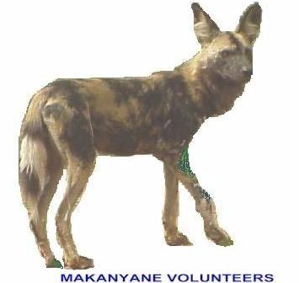 SPECIAL PROJECTS INDEMNITY FORM

PLEASE WRITE CLEARLY !

PEOPLE 17 YEARS OLD AND YOUNGER MUST HAVE THIS INDEMNITY SIGNED BY A PARENT OR GUARDIAN

SURNAME___________________________________FIRST NAME_____________________________________________

ADDRESS____________________________________________________________________________________________

TELEPHONE NO H____________________________W_______________________________________________________

CELL________________________________________FAX_____________________________________________________

E-MAIL_______________________________________________ ID No________________________________________________

OCCUPATION_________________________________________________________________________________________

DO YOU SUFFER FROM ANY ALLERGIES – IF SO, PLEASE DETAIL_________________________________________

NEXT OF KIN (NAME & TEL NO.)_______________________________________________________________________

INDEMNITY

I, _________________________________________________do hereby warrant and acknowledge that:

- My general health is good and there is nothing that renders me unfit to take part in any of the activities organized by MAKANYANE VOLUNTEERS in any of the Northwest Parks.

- I fully understand the inherent risks, hazards and dangers that are involved in any of the activities to which I may be exposed.

- I voluntarily assume the risks, hazards and dangers inherent in the said activities. I, together with my heirs, executers and administrators herby release Northwest Parks, it’s members, officers, staff and agents and MAKANYANE VOLUNTEERS members, officers, servants and agents from any liability that may arise from any claims that could be made by me or my heirs, executers and administrators arising out of my participation in the said activities or in any related activity irrespective of whether such claims arose through the negligence of any person or from any risk, dangers or hazards inherent in these activities or from any other cause whatsoever related to these activities, nothing at all excepted. I further indemnity and hold harmless Northwest Parks against any claims howsoever the same may arise.

DATED____________________SIGNATURE__________________________________________________________________

INDEMNITY - MINORS

I, _________________________________, do hereby certify that I am the legal parent or guardian of__________________

___________________________________I hereby ratify adopt and confirm the warranty, acknowledgement, release and indemnity given above and record that I have no objection to his / her / their participating in these activities conducted by MAKANYANE VOLUTEERS in any of the Northwest Parks.

DATED____________________SIGNATURE__________________________________________________________________

